1. Introduction
A fuel measuring can, also known as a calibration can, is a critical tool used in petrol stations and fuel service locations to measure and verify the accuracy of fuel dispensed by pumps. Typically made of durable materials like stainless steel or carbon steel and equipped with precise calibration markings, fuel measuring cans are essential for maintaining regulatory compliance, ensuring accurate fuel dispensation, and upholding consumer trust.
2. Purpose of Fuel Measuring Cans
The goal is to ensure that the amount displayed on the fuel pump matches the actual quantity dispensed. In many countries, regulatory authorities mandate routine accuracy checks of fuel pumps, and fuel measuring cans play an integral role in meeting these standards.
3. Design and Features
Fuel measuring cans are designed with specific features to enhance accuracy and durability:
- Material: Usually made from high-grade stainless steel, carbon steel or aluminum to prevent contamination of the fuel and ensure durability under repeated use.
- Capacity: Commonly available in volumes of 5 liters, 10 liters, 20 liters or even larger sizes to accommodate different fuel pump capacities. The 10-liter can is especially popular for standard pump verification.
- Graduated Markings: The cans are marked with precise graduations, allowing users to measure fuel down to fractions of a liter.
- Spout or Pouring Mechanism: Many measuring cans come with a built-in spout to make it easier to pour fuel back into storage tanks or vehicles after measuring.
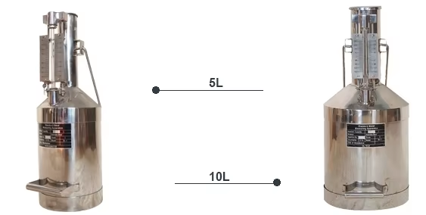
- Sealing Cap: A tight-sealing cap ensures that fuel does not evaporate or spill, ensuring an accurate reading
5 Liters Measuring can 10Liters Measuring can
4. Usage in Petrol Stations
Fuel measuring cans are used in several key operational and regulatory processes:
Pump Calibration: Stations periodically use fuel measuring cans to verify that pumps dispense fuel accurately. If discrepancies are found, adjustments can be made to recalibrate the pump.
Verification During Inspections: Regulatory authorities often require petrol stations to demonstrate compliance by testing fuel pumps with certified measuring cans during inspections.
Routine Maintenance: Regular checks with fuel measuring cans help identify issues in pump accuracy early, such as calibration drift or wear and tear of pump components.
5. Conclusion
Fuel measuring cans are a vital tool in the fuel retail industry, offering precision and accuracy that help stations comply with regulations, maintain consumer trust, and avoid financial losses due to inaccurate fuel dispensation. As a simple yet effective tool, the fuel measuring can plays a central role in the daily operations of petrol stations, regulatory compliance, and overall customer satisfaction. Regular maintenance and periodic verification are essential to uphold the can’s accuracy and ensure it remains an effective tool in the fuel dispensing process.

